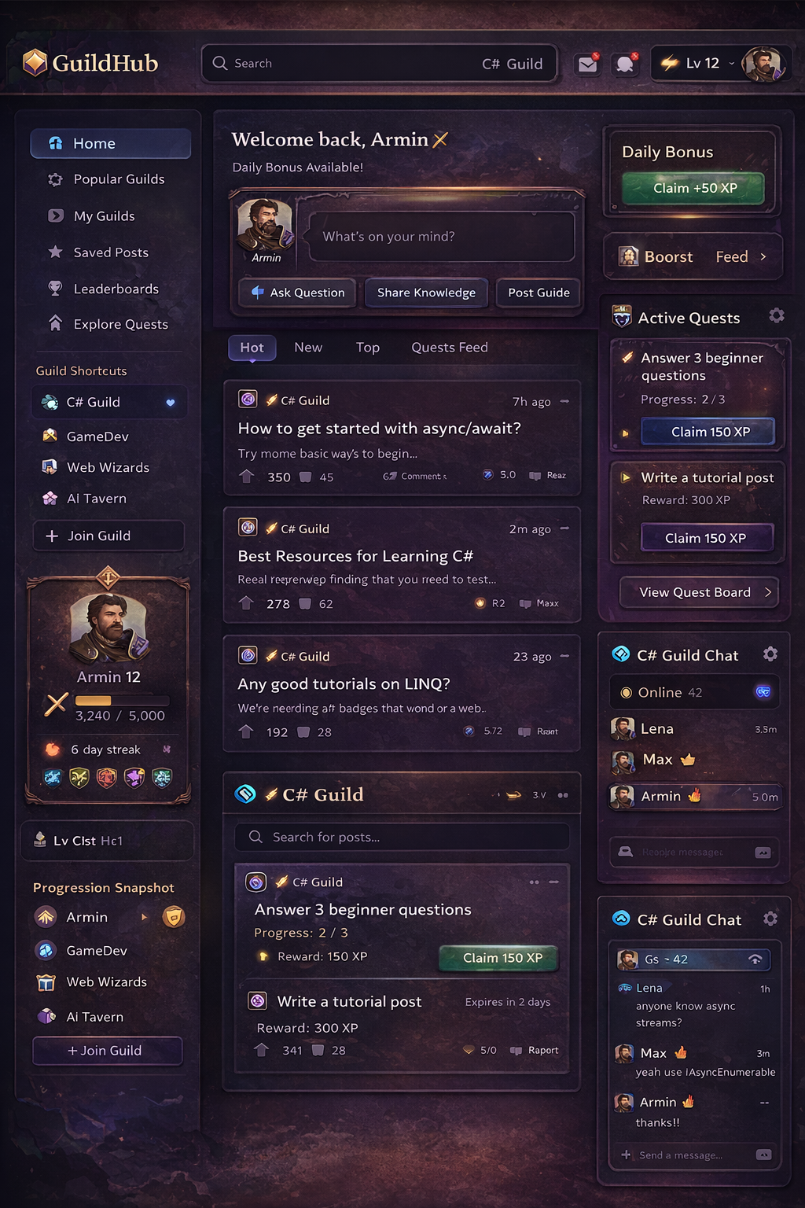

Project Description – Gamified Community Discussion Platform
The primary goal of this application is to create a community-driven discussion platform that combines traditional forum functionality with gamification and real-time interaction. While platforms such as Reddit focus mainly on threaded discussions and voting systems, this project aims to improve engagement and contribution quality by introducing progression mechanics, quests, and community-based rewards. The application encourages users not only to consume content, but to actively participate, help others, and complete structured challenges that benefit the community.
The application targets students, hobbyists, and online community members who enjoy participating in discussions but also value recognition and measurable progress. Many users of online forums tend to remain passive readers, and existing platforms offer limited incentives for meaningful contributions beyond reputation points. By integrating experience points, levels, and achievement systems, this platform motivates users to contribute consistently and constructively. Moderators and community leaders are also key users, as the system provides tools for managing quests, validating contributions, and maintaining discussion quality.
The concept is inspired by several existing platforms. Like Reddit, the application organizes content into communities and allows users to post, comment, and vote. From Discord, it adopts real-time communication within communities, allowing members to interact instantly alongside structured discussion threads. The progression and challenge-based elements are influenced by platforms such as boot.dev, which demonstrate how gamification can increase user motivation and retention.
However, this project is not a copy of any existing platform. Its defining feature is the integration of a quest system where communities can create structured challenges that reward users for helpful participation, such as answering questions, writing tutorials, or assisting newcomers. Combined with experience points, levels, badges, and role progression, this creates a system where reputation reflects actual contribution rather than simple activity. The inclusion of both long-form discussion posts and real-time chat further distinguishes the platform by supporting different types of interaction within the same environment.
From a technical perspective, the project demonstrates core web application concepts such as manual authentication, session management, role-based authorization, database interaction without ORM frameworks, and real-time communication. This ensures the application serves not only as a functional community platform but also as a strong demonstration of backend and architectural understanding.
Overall, the application fulfills the need for a more engaging and structured discussion environment by combining forum interaction, gamification, and real-time communication into a single cohesive system.

